# ER/ERR Diagram

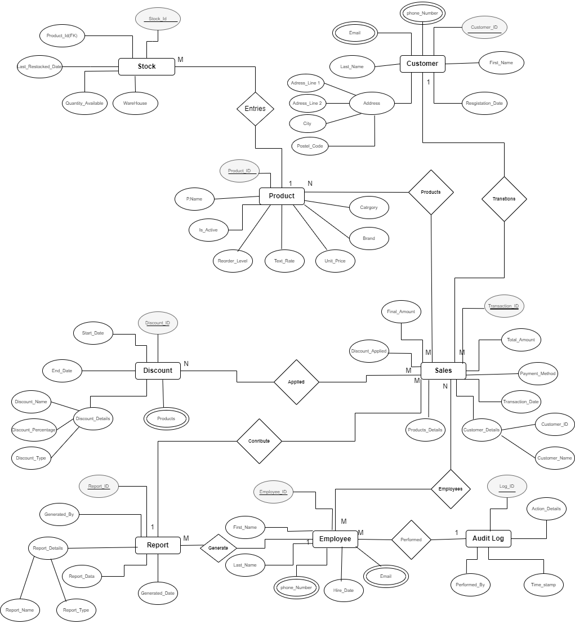

Figure 1 ER/ERR Diagram

**Assumptions for the ER/EER Diagram**:

1. **Customer**:

* Each customer has a unique CustomerID.
* Customers can register in the system, and their details such as name, email, and phone numbers are stored.
* A customer can make multiple transactions (1:M relationship with Sales).

1. **Product**:

* Each product has a unique ProductID.
* Products belong to specific categories.
* ReorderLevel indicates the minimum quantity of a product before it needs restocking.
* **Product - Stock:** Each product can have different stock levels across various warehouses.(1:M)

1. **Stock**:

* Each Stock is uniquely identified by a Stock_ID.
* Stock shows us the last Restocked date.
* Stocks are stored in a WareHouse.

1. **Discount**:

* Discounts are applied to Sales, creating an M:N relationship between products and Sales.
* Each discount is uniquely identified by a DiscountID and includes details like Discount Details, start date, and end date.
* Discounts can apply to multiple Sales.

1. **Sales**:

* Each sales transaction is uniquely identified by a TransactionID.
* Sales include details of the customer making the purchase, the Discount method, and the Employees.
* Discounts applied during sales are linked to the transaction.

1. **Employee** :

* Employees are uniquely identified by EmployeeID.
* Each employee have Employee Id, contact information, First and Last Name .
* Employees perform actions logged in the AuditLog.

1. **Audit Logging**:

* Actions performed by employees (e.g., adding, modifying, or deleting data) are recorded in the AuditLog with details of the action and a time.

1. **Report Generation**:

* Reports are uniquely identified by a ReportID and include details such as the report type, generation date, and generated by (an employee).
* Reports are generated daily or monthly to help the owner make informed decisions.
* Sales and other operational data contribute to report generation (1:M relationship between Reports and Sales).

1. **Relationships and Cardinality**:

* A customer can have multiple transactions (1:M between Customer and Sales).
* A Sales can belong to multiple discounts, and discounts can apply to multiple Sales (N:N between Sales and Discount).
* Employees can generate multiple reports and perform multiple actions logged in the audit (1:N relationships).